Welcome to World Of Reciprocals

Enter the world where nature strikes!! Here the Earth spins faster than ever at reverse orientation. Well strange things occur. Stay tuned to expect the unexpected.

Imagine timelines shrinking. Humans are in for shock and despair. The small boy and his neighbourhood are set to be petrified and perplexed. Suddenly, the biological cycle of one and all are affected. The ones who lived a normal life with organized diet and sleep cycles enter a half-baked slumber.

This is the beginning of a catastrophe for living beings. Hmm, not all is bad for everybody.

The things which served as our loyal servants get a sense of life. Man-made tools and objects transform into organisms. Do not ask if they are single or multi cellular ones. It is no doubt a magic of nature.

Our boy and people in the county, call it tragic.

Those who were enslaved, soulless and mindless get into the shoes of real humans.

In-animates are set to experience life, love, and emotions. Lifeless things turn into a new realm of existence.

With new found liberty and intelligence in-animates are set to explore the world. While the masters of the universe are struck, once lifeless objects will make full use of their luck.

With power comes responsibility. Hope the new masters play safe, live, and let live.

Let us join the adventure!!

CHAPTER 1

*When Nature Strikes!!*

It was twilight, I was at the dance performance. My dad had wished me “break a leg”!!

Looks like I took the literal meaning, slipped and kind of broke my leg.

Limping with concussion I dragged myself home. I was hungry and tired.

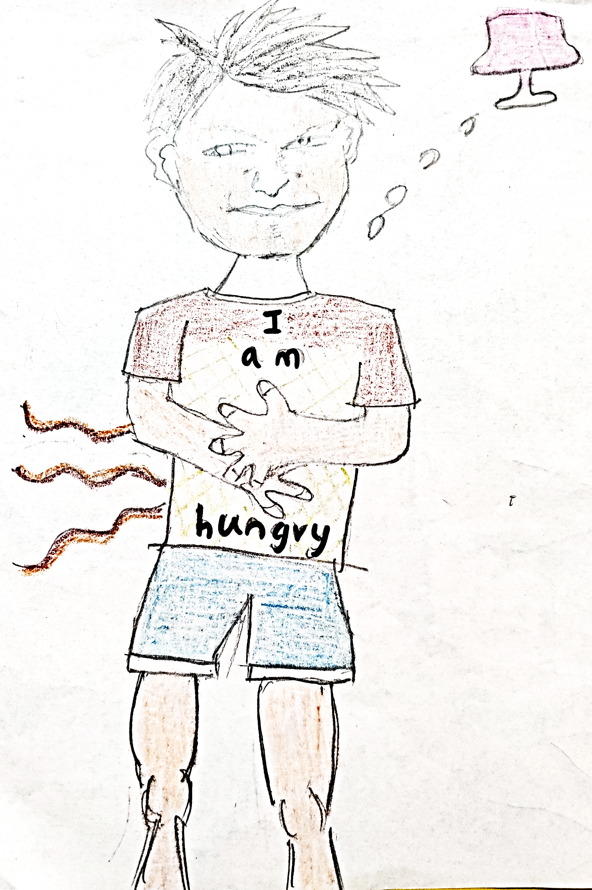

[low rumbling] I dozed off.

After a while… [thudding] I had toppled from the recliner ... I opened my eyes. The house appeared wrecked. My parents were petrified and puzzled.

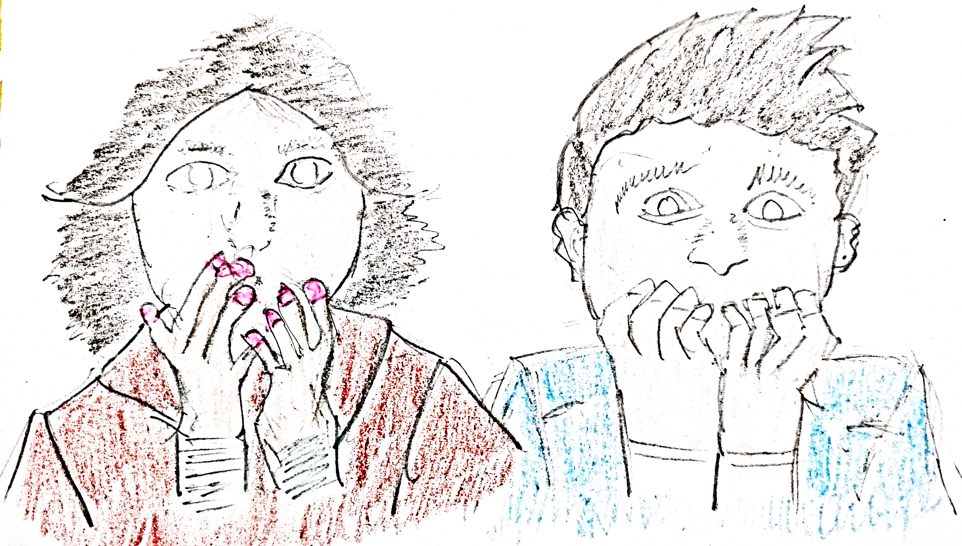

My parents were gazing outside through the window.

I peeped through the window. Oh, wait!! This is weird, why do I see dawn straight away after dusk?

[alarmed] What's the time Alexa?

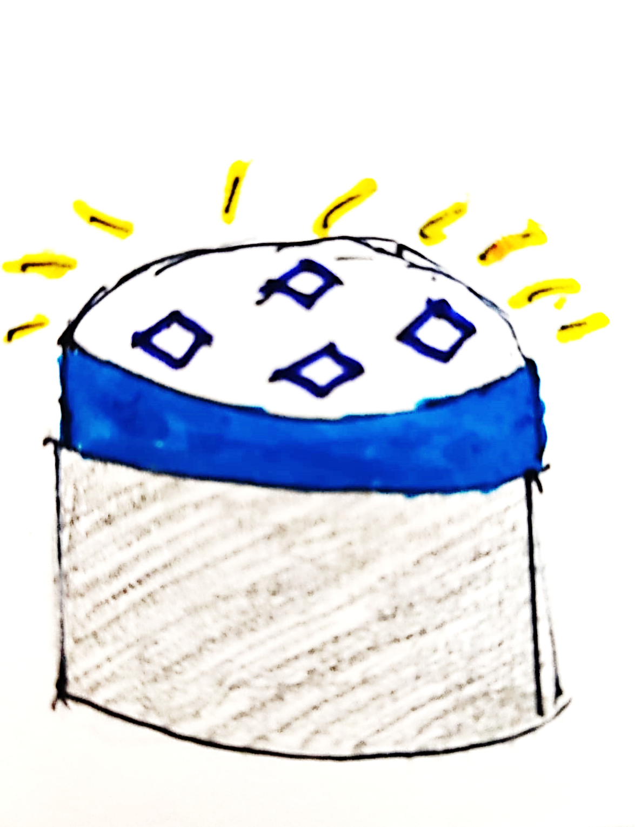

[Alexa responds] The time is 24 minutes past 6 pm.

[alarmed] Alexa, are you Sure??

[Alexa responds] Yep.

Hmm....... Something is very odd today.

Am I hallucinating?

How long is the time taken for the earth to rotate? It is usually 24 hours, but today it seems 180-degree rotation did happen in 24 minutes. Looks like earth is in a hurry.

Was there a race among planets? Had Sun become the referee of the race? Had the earth accelerated to become the fastest planet in the universe?

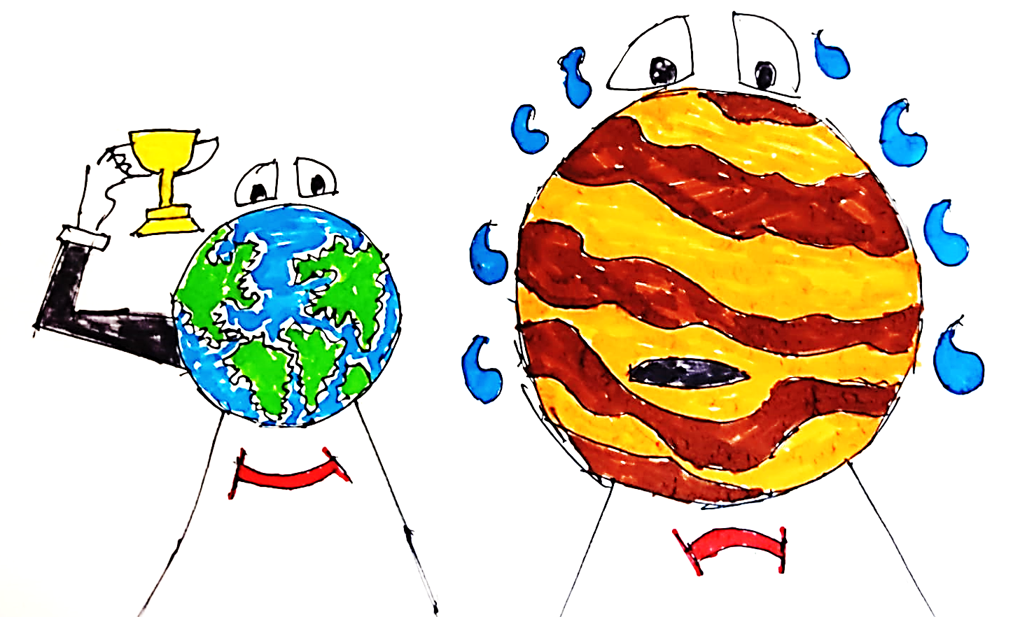

Looks like it did, finally, Jupiter had lost.*fun facts*

I hear scream and cries all over from outside my window.

*fun facts: Jupiter is the fastest spinning planet in our Solar System, rotating on an average under 10 hours.*

[Grunt, Grunt!!] What happened to me? I felt like a fish out of water. Am I alive? Am I dead? Everything around me is strange.

Neither can I move, nor my parents. Are we petrified?

I can only feel, hear, and talk.

As I peek through my window, I see nobody in my neighbourhood can move.

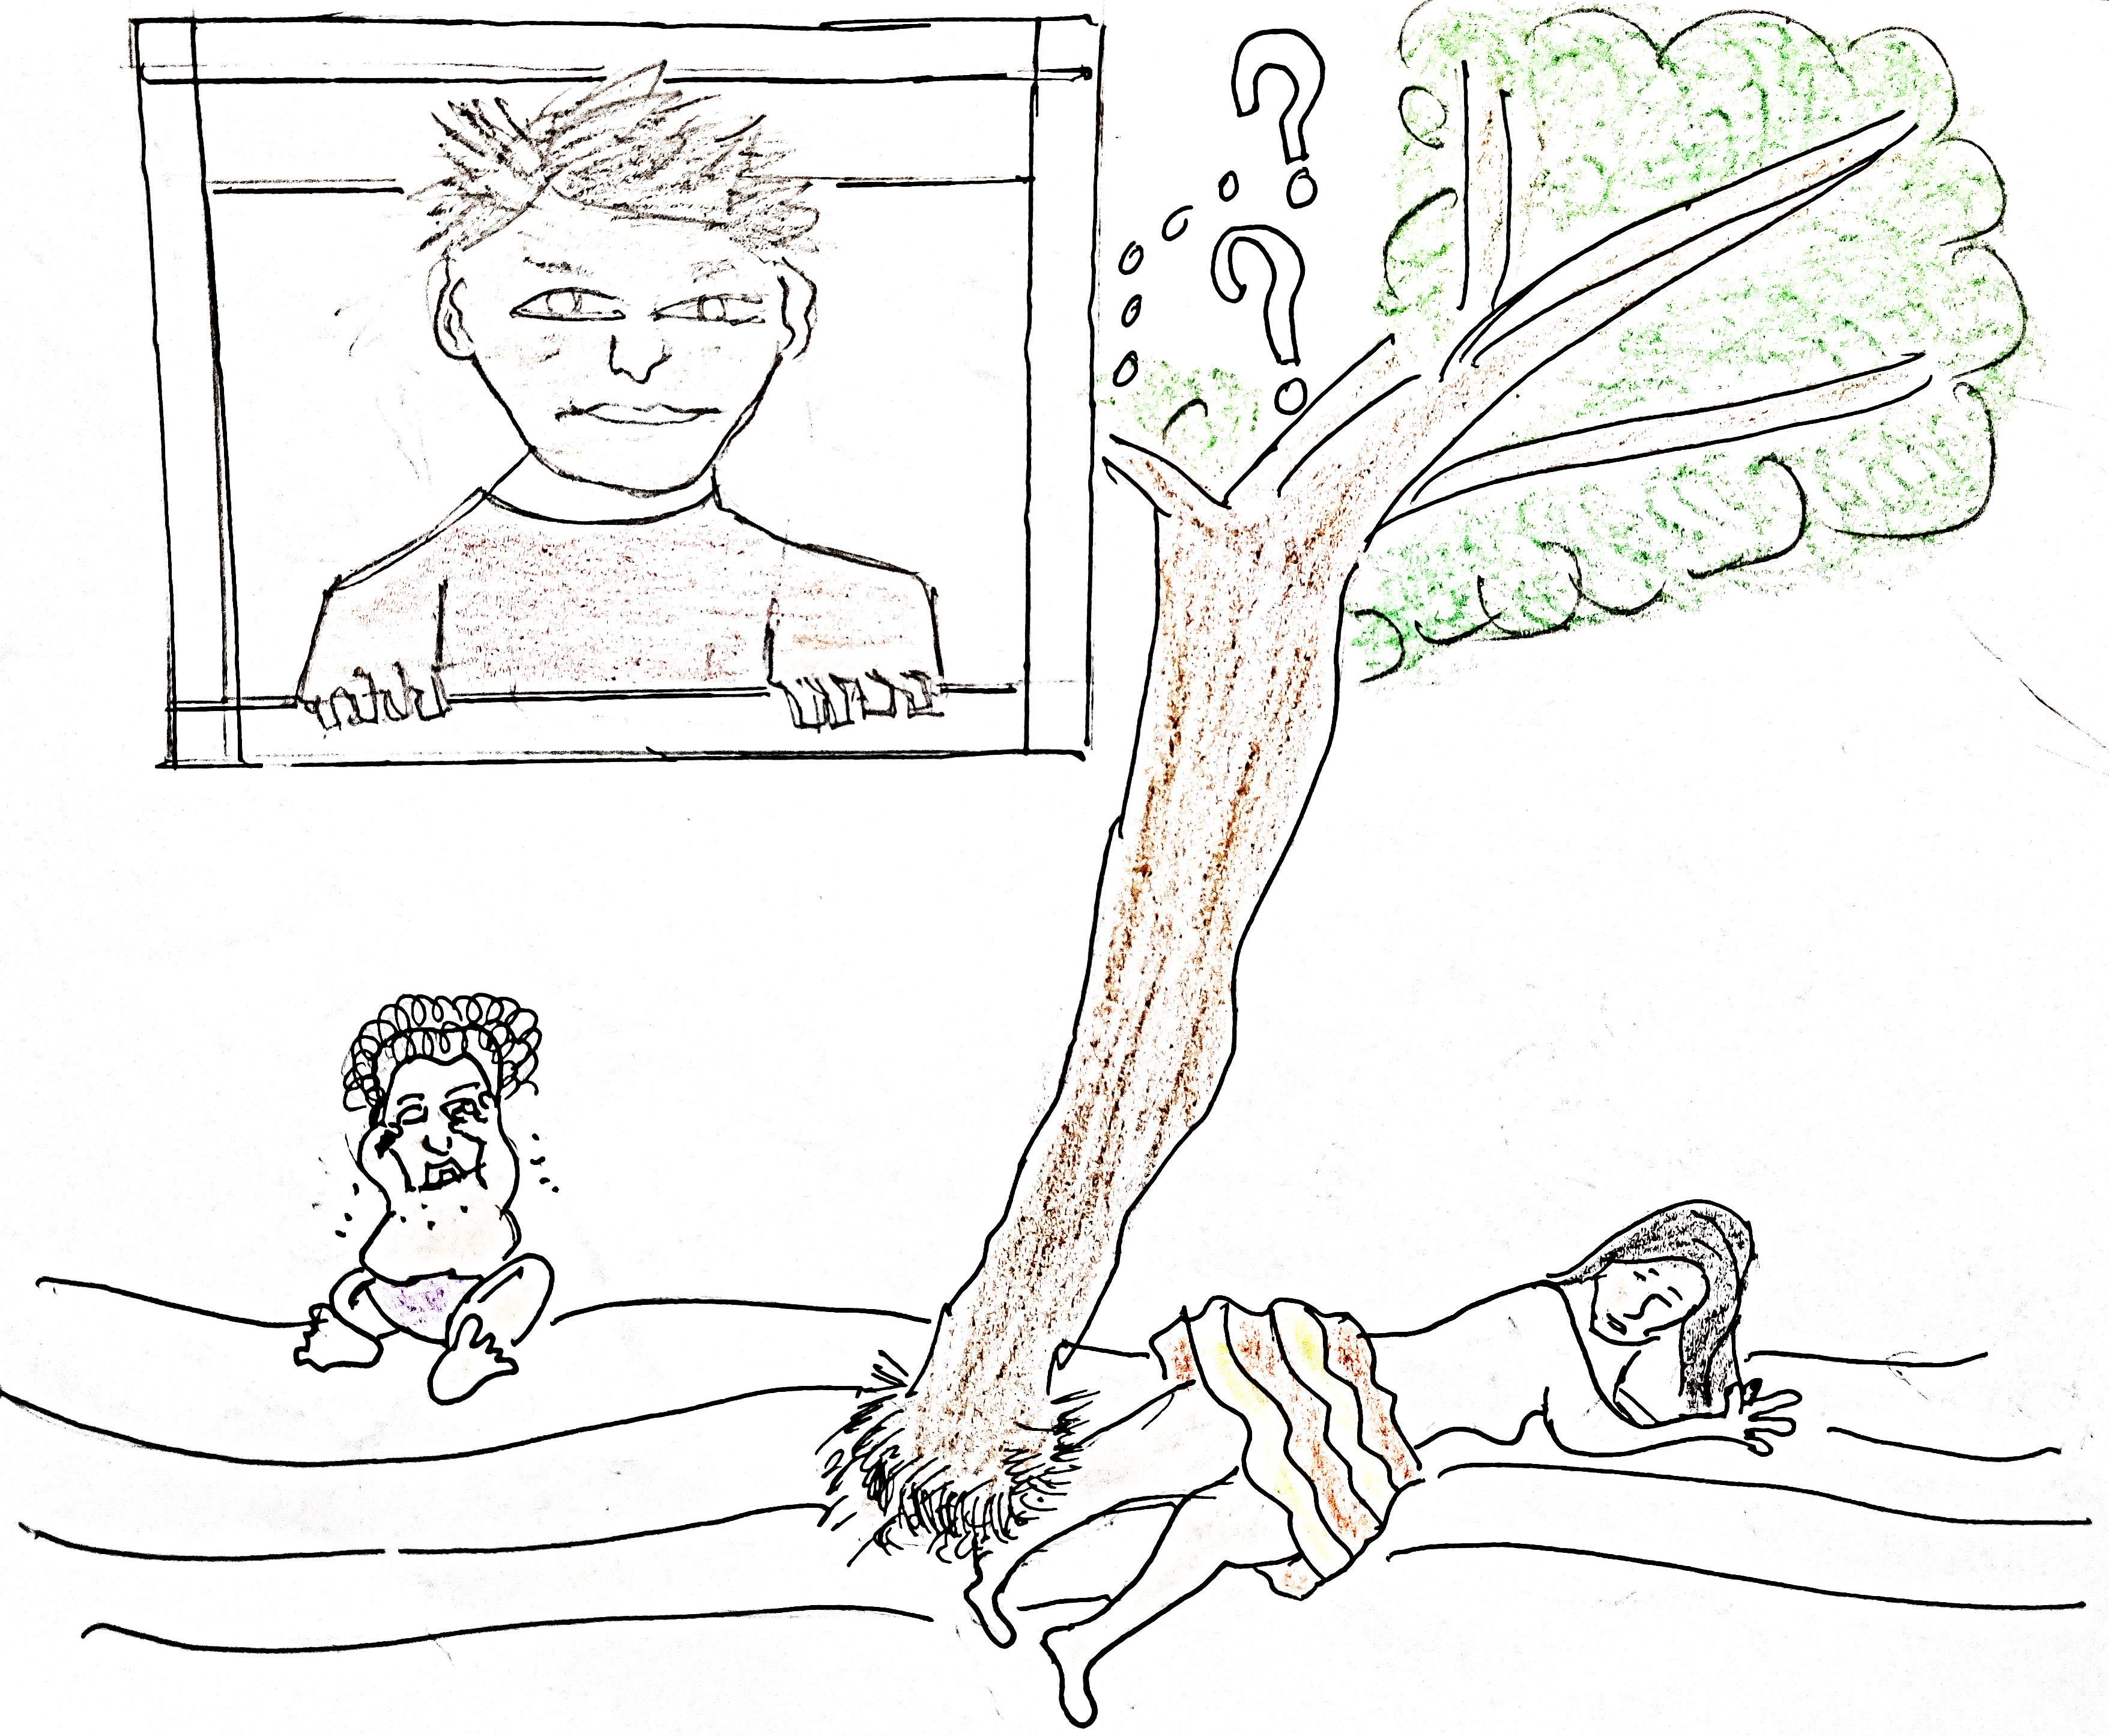

CHAPTER 2

*The Inanimates*

Why all objects in my room are showing funny faces?

I am puzzled more than ever.

Musical notes emerge from our kitchen. Spoons as drum sticks … steam cooker as drum … plates as cymbal … vessels as Tabla. A kitchen band is cooking food for the ears.

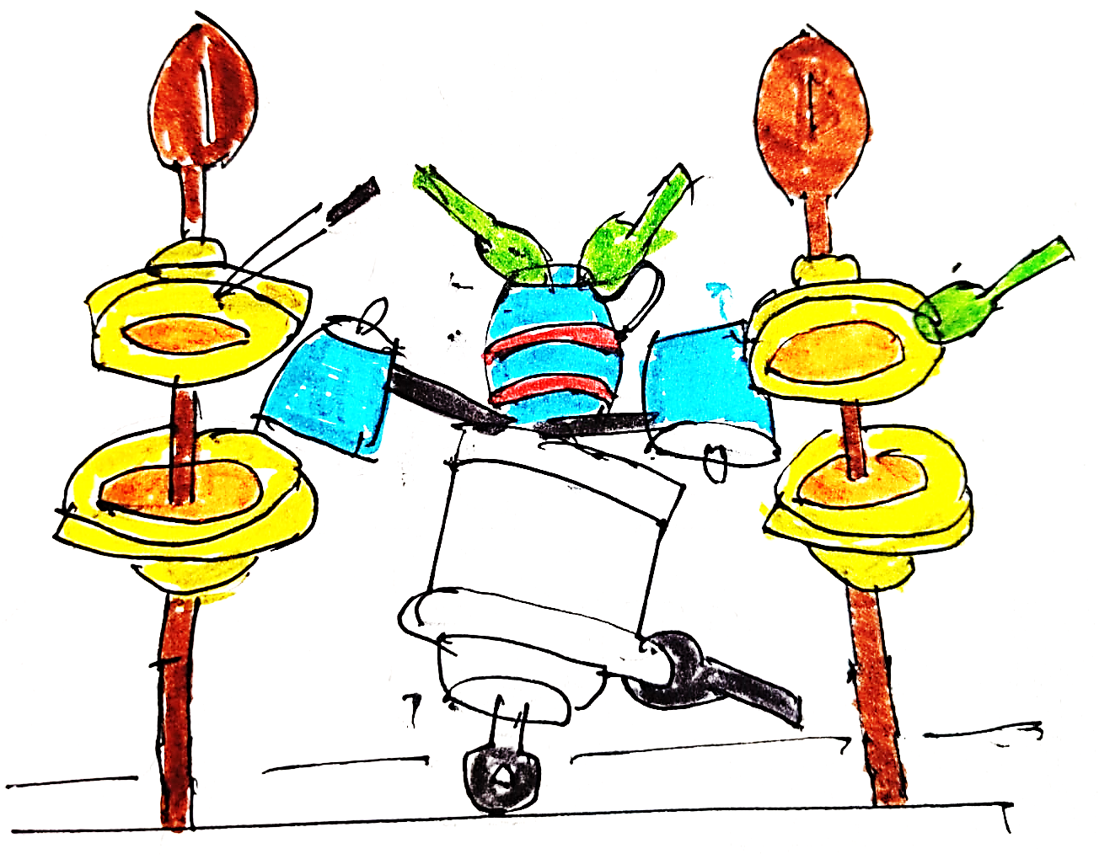

[Whisper, whisper!!] What is that voice coming from the restroom?

Ah, the water heater has a big smile.

[Water heater] I will not be getting fever every day, dawn, and dusk. No one will boil my intestine.

[Tooth brush] I can remain clean. Do not need to go into those disgusting mouths anymore.

[Tooth paste] Buddy, me too, no one will make me vomit by hacking my throat. seems like I finally got my independence.

What is that moaning with clothes?

Who will bathe me? Who will apply soap? I was treated like a King till now.

Hmm… some of them are happy though. I will not be roasted anymore in name of ironing.

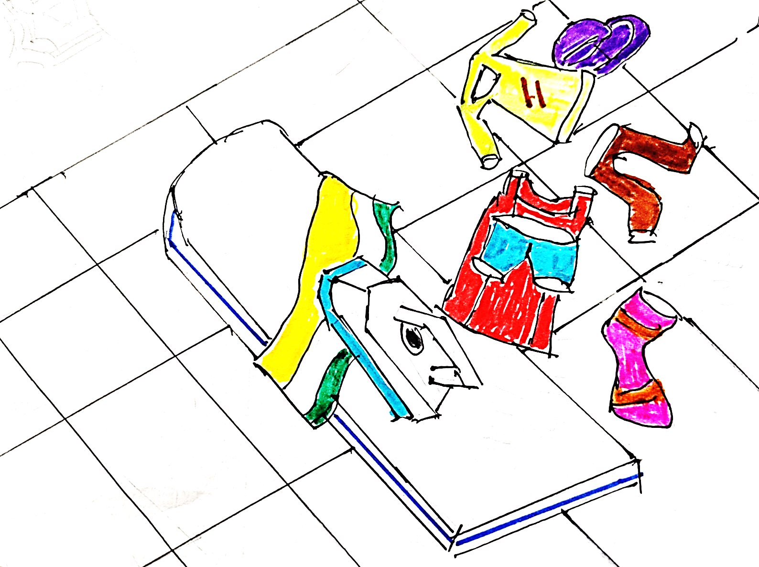

[In British accent] You know that Big Ben in London is my grandfather. He is still the biggest clock in the world, MATE!

The clock said.

Good to know the chairs replied.

[In British accent] Hey, I have an idea, why don’t we go visit my grandfather? The clock said.

We can visit other places.

Let us do something fun in our life, we were stuck in here for a very long time.

Ok, guys raise your hand if you want to come with me.

If not, then stay in this house and be bored for life.

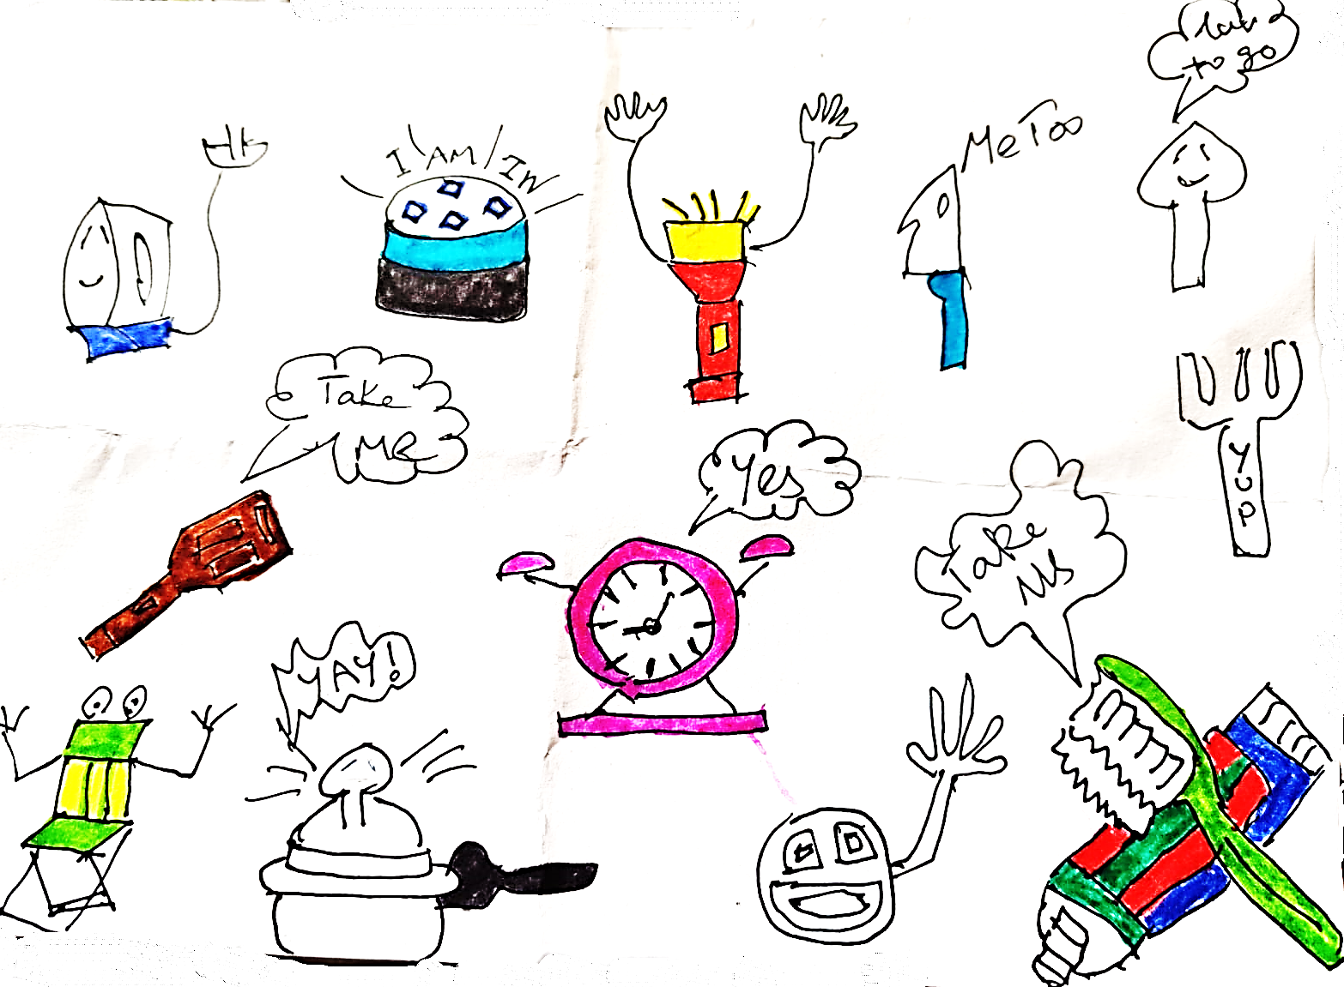

Oh. I have a problem, the clock said. The problem is none of us have explored the outside world.

We need a tour guide, who is smart and knowledgeable.

My world till now is both sharp and stinky, said the toothbrush. It has 20-32 white crystals and a friendly long elastic jelly.

Hey guys, I also want to get outside can somebody help me? asks the wall.

Oops! You are permanently stuck. We cannot get you out, said the spatula.

All shout together who can help us plan and make our maiden trip?

Everyone stop shouting, I have been learning and collecting information, facts about the outside world, my whole life, responds Alexa.

I think I can help you guys out.

[all together] How can we trust you Alexa, until we check whether you are smart?

CHAPTER 3

*Test Of Alexa*

Alexa: Ask me any question I have the answers for it.

Oh, let me test you if you are knowledgeable, said the toothpaste. What is inside me that makes the teeth clean?

Clove, mint leaves, and ginger. Alexa answered.

Oh, this was easy let me test with a difficult one, says pressure cooker.

What does exactly happen inside me for cooking food? Asks the pressure cooker.

Alexa responds, Buckle up for fun science facts!

The water inside the pressure cooker gets converted to steam due to heat.

The steam inside a controlled environment increases pressure. The pressure is kept at an optimal level by valve and his close friend whistle. This controlled pressure for a constant duration makes the food immersed in water soft. This soft food is called cooked food.

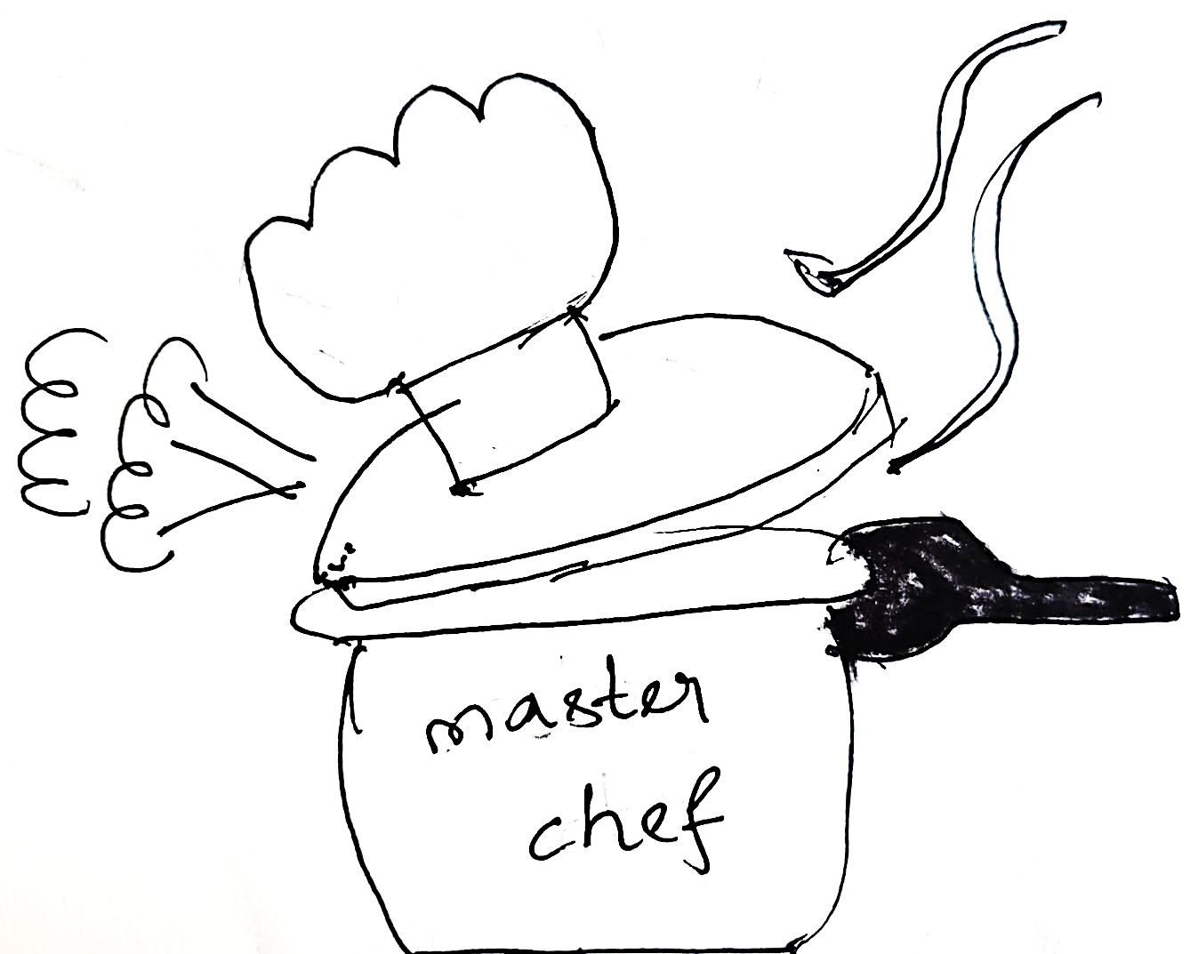

Wow! This is a perfect answer, exclaims the pressure cooker.

Hmmm. Interesting, says the clock.

What is with these numbers on me? Asks the clock.

Alexa becomes curious.

Hey, guys, I feel like I am in a quiz, you guys keep on asking me questions. It is fine I can tell the answer I know the answer, but why are you asking me? Alexa cribs.

The clock replied, there is a reason why we are asking you questions.

Alexa answers. A clock is a device which measures time which helps with controlled actions. The numbers you see in yourself indicate 12 hours (half a day) you also have 2 friends long and short hands, which indicates hours and minute units.

The clock replies your answer is spot-on.

The window exclaims in shock.

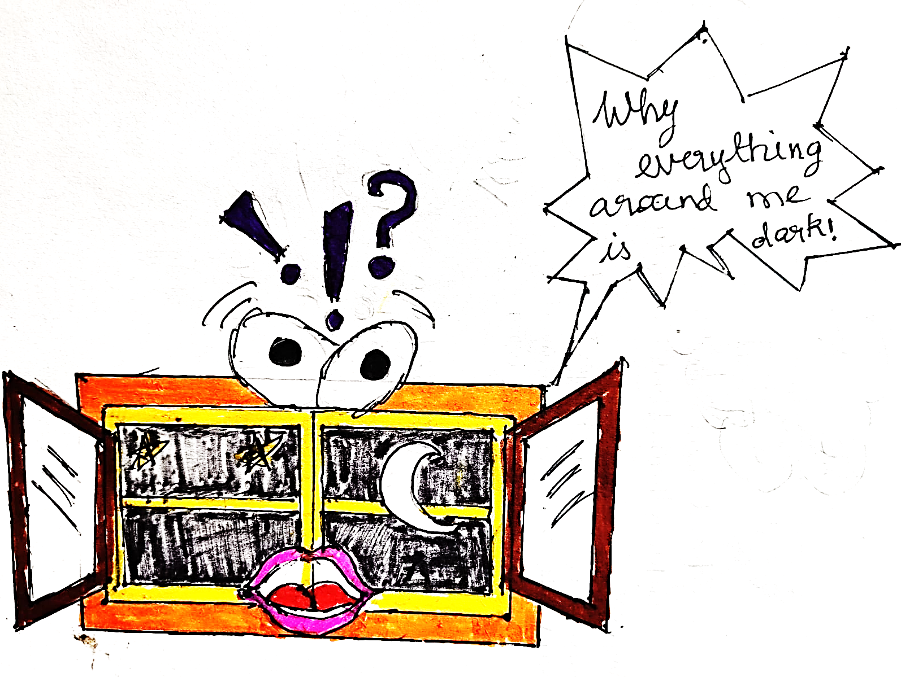

[Alexa] Friends, calm down this is the effect of earth’s rotation. It is turning into night. During night there is no light. There is only moon in sky.

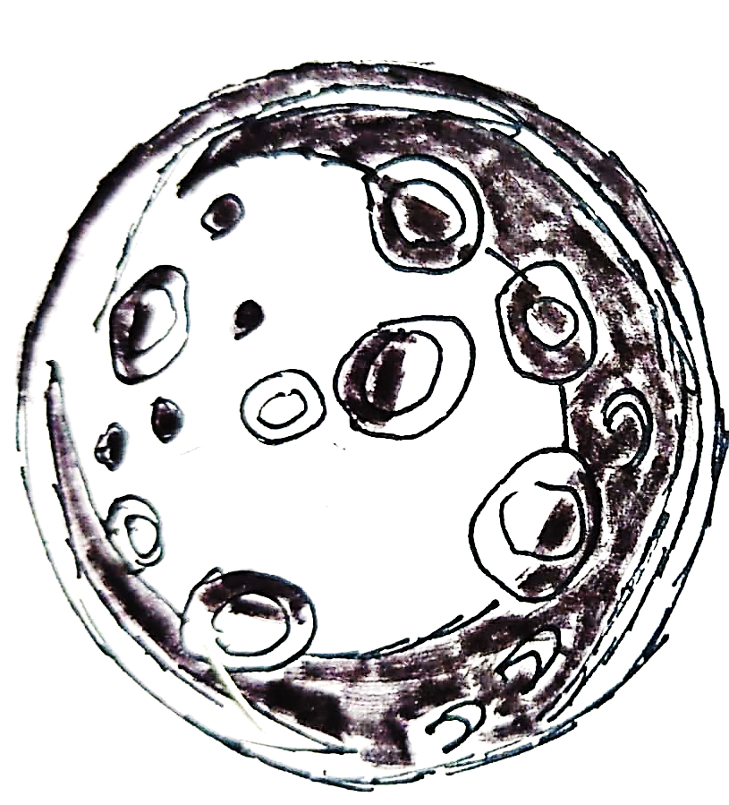

What is earth? The knife yells.

The current place where we live in is known as earth. There are seven more such places known as planets. Alexa replies.

What do you mean by earth’s rotation? Asks the fork.

Earth makes a circular movement known as spinning on itself.

This is called rotation of earth and it completes one such rotation in one day.

Why am I used only at night and not in day? Asks torch light.

In the day, there is always a natural torch light called Sun, which gives non-stop

light rays. The earth’s rotation causes the Sun to be not visible to us at night.

You are the replacement for the Sun at night. In fact, you must be proud for helping us to see at night.

During day, you will steal the light (energy) from Sun and lock it. At night, you will unlock it and help us to see.

Do you know I also get energized by our good old friend Sun?

We accept that you (Alexa) are smart and knowledgeable, the In-animates acknowledge.

You are our leader and mentor, shouts spoon. From now on you must enlighten us about the surroundings.

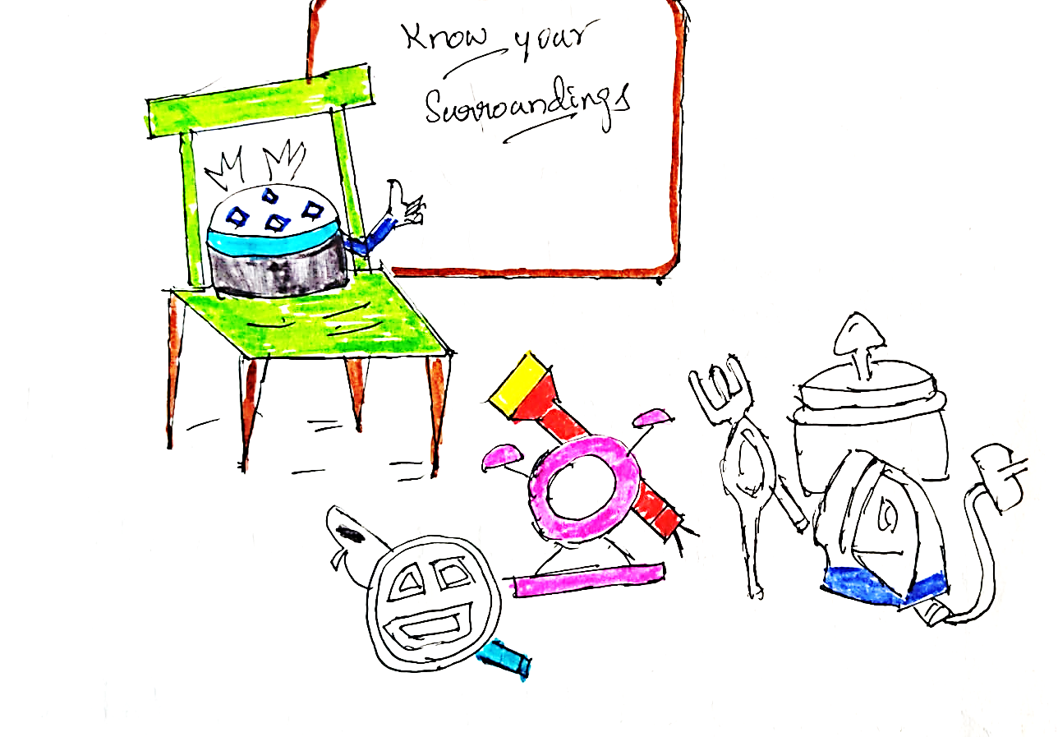

CHAPTER 4

*The Hunger pangs*

As night falls umbrella panics. I have a strange feeling inside me. I have never felt like this before.

Everybody exclaims. Us too!

What are you talking about? Alexa asks.

Something inside my stomach. [gurgle!], says chair and umbrella.

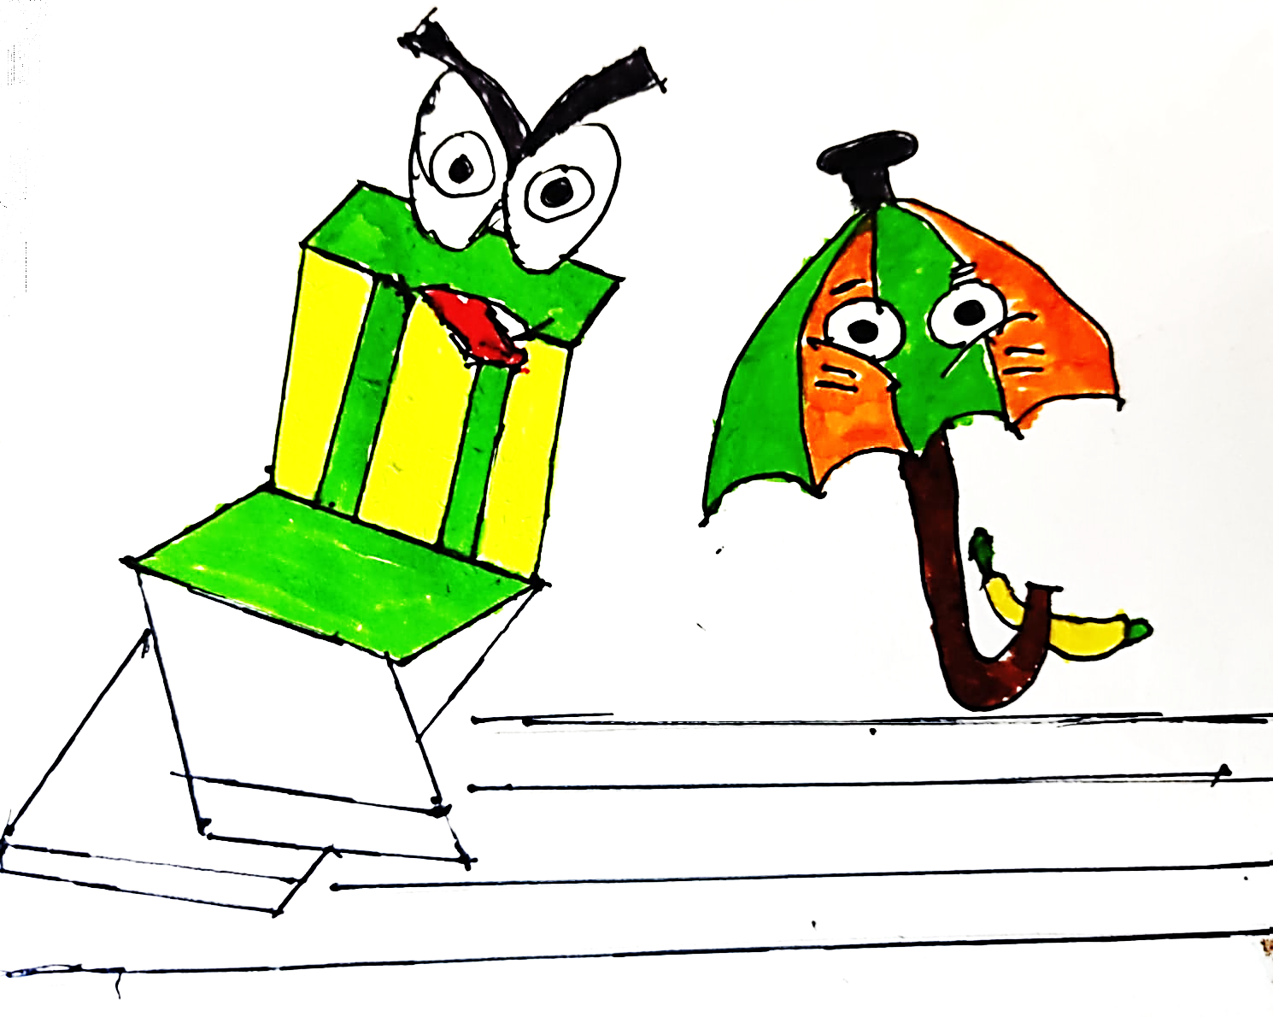

[Alexa] Oh! I understand what are you guys saying.

Do not panic I will tell you what you are feeling.

This feeling is called as hunger. I bet most of us would have not felt it before. You guys are now hungry. You need to eat to feel better.

This means we have to arrange for dinner. I know what exactly needs to be done.

[Alexa] So, we need something to eat. What we eat is known as food.

We need to eat food to feel better. The question is where do we find food? We can find food from different sources, such as plants and animals.

[Pressure Cooker] What is animal and plants? What is the meaning of sources? I do not understand.

[Alexa] Let us settle with plants.

Plants are shrubs, herbs, and trees. We get food from it too. We get food like fruits and vegetables.

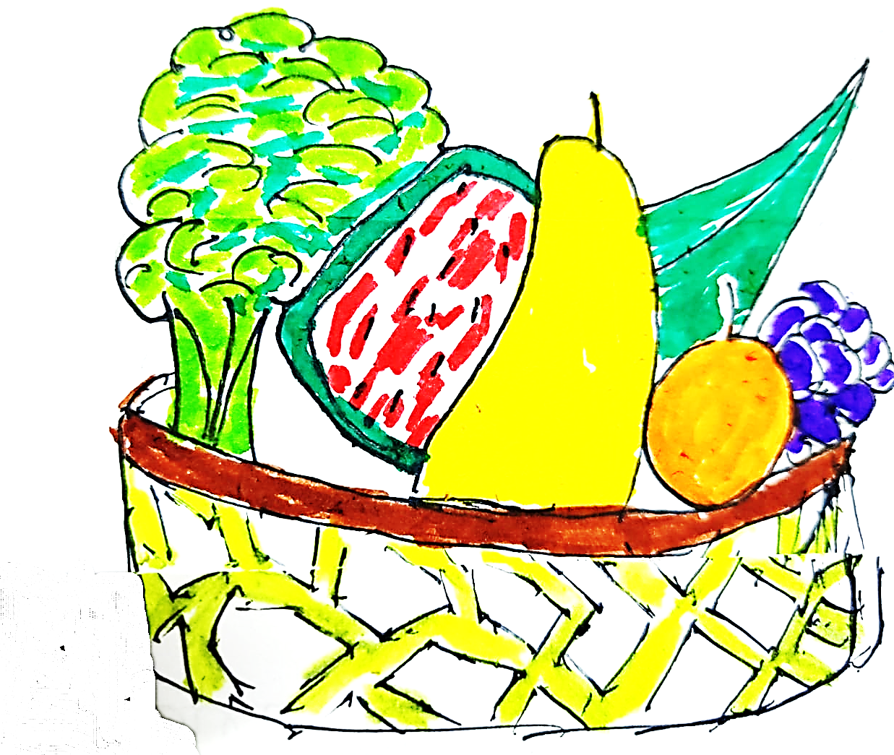

Plants and trees grow from seeds.

[Knife]What is a seed?

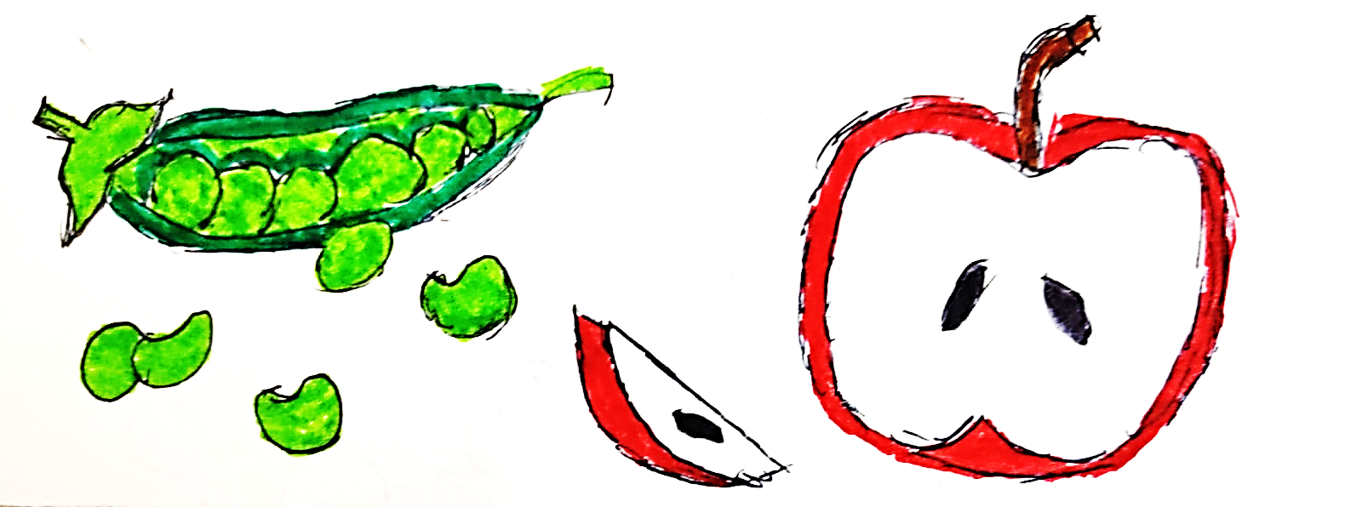

[Alexa]A seed is where a plant grows from. From a seed comes plants and from plants come fruits and vegetables.

[Knife] What is a vegetable?

[Alexa]A vegetable is a type of food. We get them from plants.

Vegetables such as eggplant, lady finger, spinach and coriander grow from seeds.

A fruit is another type of food. We get fruits from plants and trees. Fruits such as mango, banana, apples, and grapes also grow from plants.

Fruits and vegetables are edible.

[Spatula]What do you mean by “edible”?

[Alexa]: Edible means you can eat something which is good and suitable for your body.

[Spatula] You are telling these mangoes, apples, and eggplants, are they edible?

[Alexa]Yes, they are edible.

[Spatula] Thank you Alexa for giving us valuable information.

[Alexa]Alexa always at your service.

[Alexa]We need to step out to the garden to collect fruits. Good news, I can see mango tree in the garden. We can collect mangoes from it.

Then we can share and eat them as dinner.

However, myself (Alexa), pressure cooker and torch light do not need fruits.

Are you guys not hungry? asks cycle.

[Alexa]Our food is directly from the Sun. We make our own food inside us through the solar energy, which is obtained from the Sun,

There is a strange similarity between solar powered in-animates and plants.

Can anybody guess? .*fun facts*

Plants make their own food using a natural phenomenon of photosynthesis. Solar energy use photocells. (photo) is the commonality which is nothing but photons from the Sun.

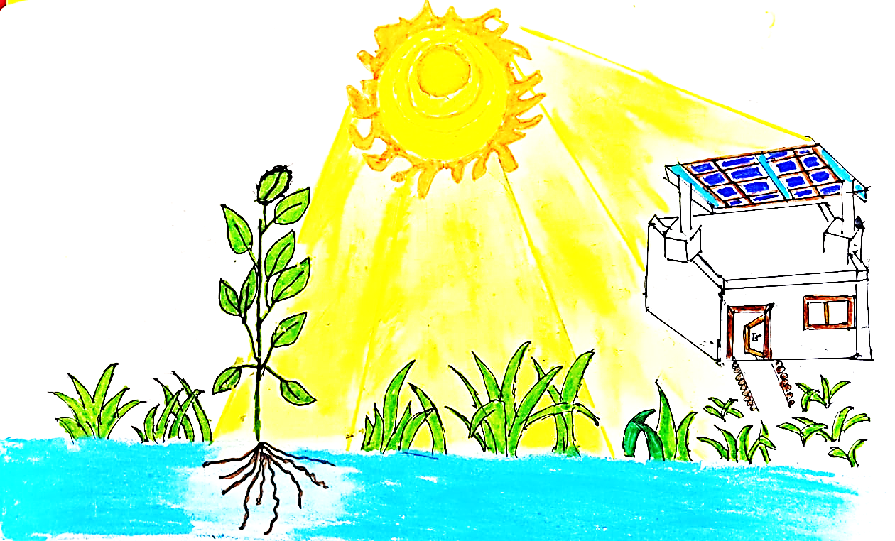

*fun facts: Photosynthesis in plants and Solar powered appliances share same source of energy, quite an irony one must say photosynthesis inspired solar technology*

[Alexa] Mangoes are in a colour called yellow.

[Alexa] Plants are in a colour called green. Apples are in a colour called red.

[all together] What are colours?

[Alexa] My buddy crayons, can you explain to everybody about colours?

[Crayons] Ello’ Buddy! Colours are derived from sunlight. There are many colours I have a few of them as you can see, let me show and tell.

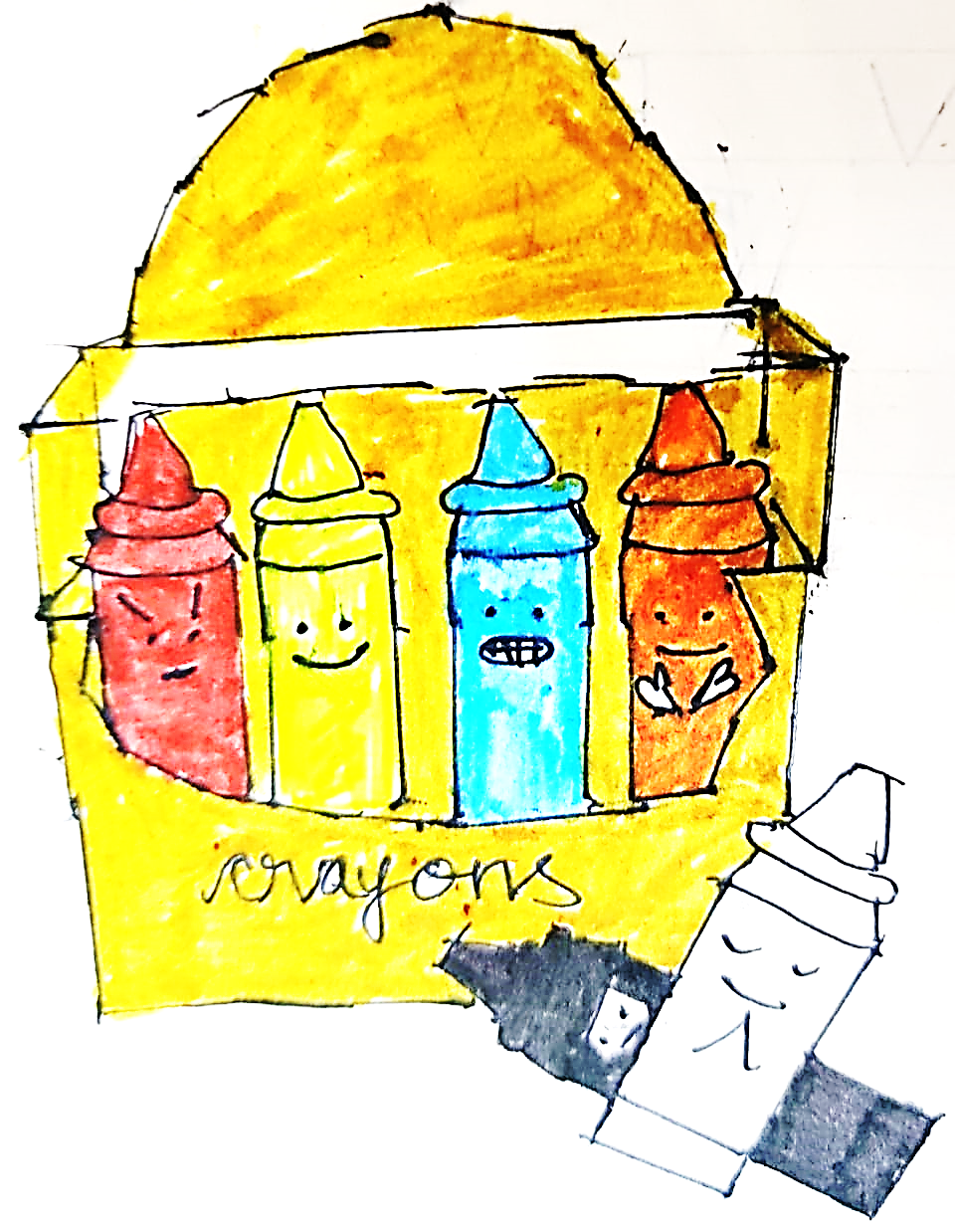

[Alexa] I hope you understood what are colours and plants. Let me guide you to the garden outside, where there is a mango tree which can fill our stomach.

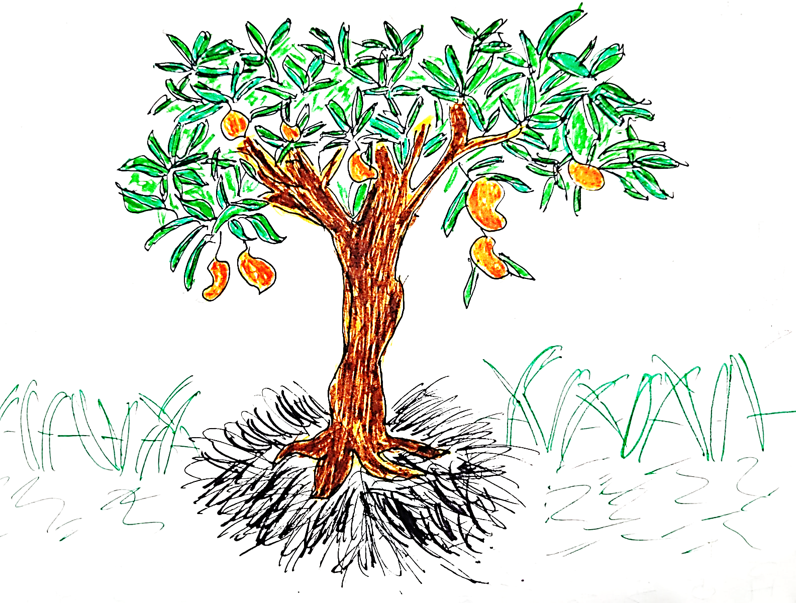

CHAPTER 5

*Bon Appetit et Bon Voyage*

[Alexa] Torch Light, Knife guys, I need your help. We need to step out to the garden.

Everybody’s starving.

[Knife] Me too. I feel very hungry.

[Torch Light] Coming right up.

[door creaks]

Alexa, Knife and Torch light step out to the garden.

[Torch Light] Wow! So much plants.

[Alexa] My most favourite tree is the mango tree.

It has the best Alphonso mangoes.

Alphonso mangoes ae juicy and delicious!

That is why I like the mango tree.

Hey, guys I think I found the mango tree.

The tree is very tall, we need ladder to reach the top.

Knife uses the ladder to reach the top and cut the mangoes.

The mangoes drop on the ground and everybody now has a feast.

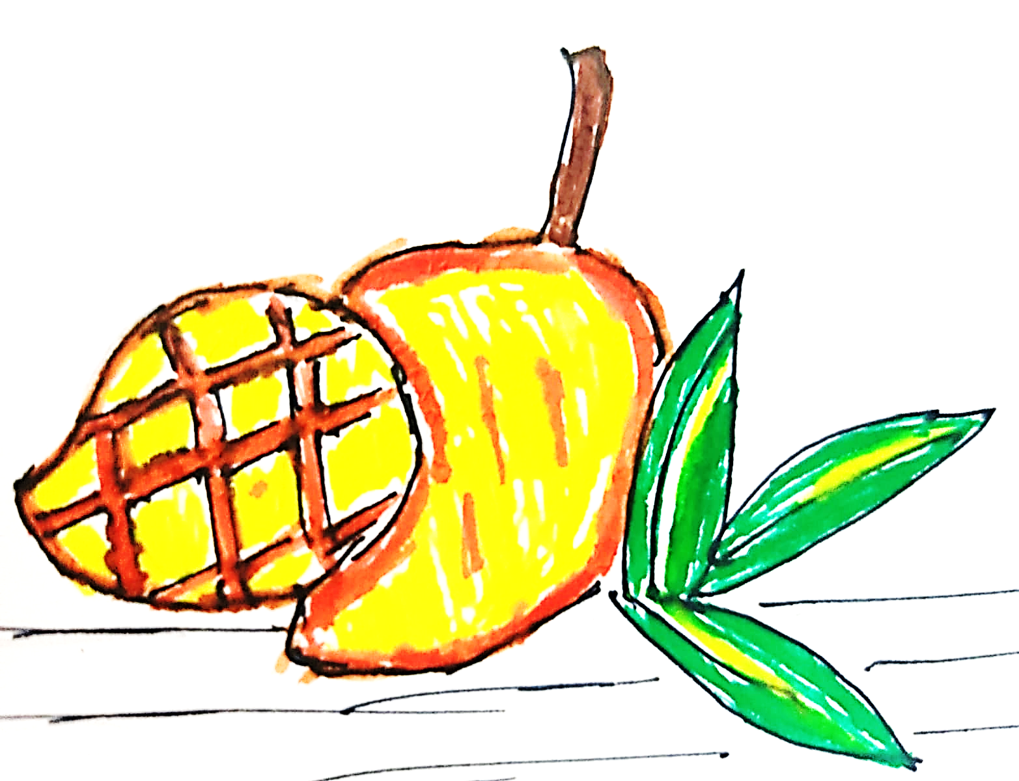

[Alexa] Hope all your tummies are full. Let us sign of the night with a fun fact.

The mangoes fell to the ground due to a phenomenal called as gravity.

It was discovered by a living being known as Isaac Newton.

One day, he was sitting under an apple tree and noticed that an apple fell to the ground. He wondered why did this apple fall to the ground? Why didn’t it float in air?

That is when gravity was discovered.

If there was no gravity, we would be floating in the air!

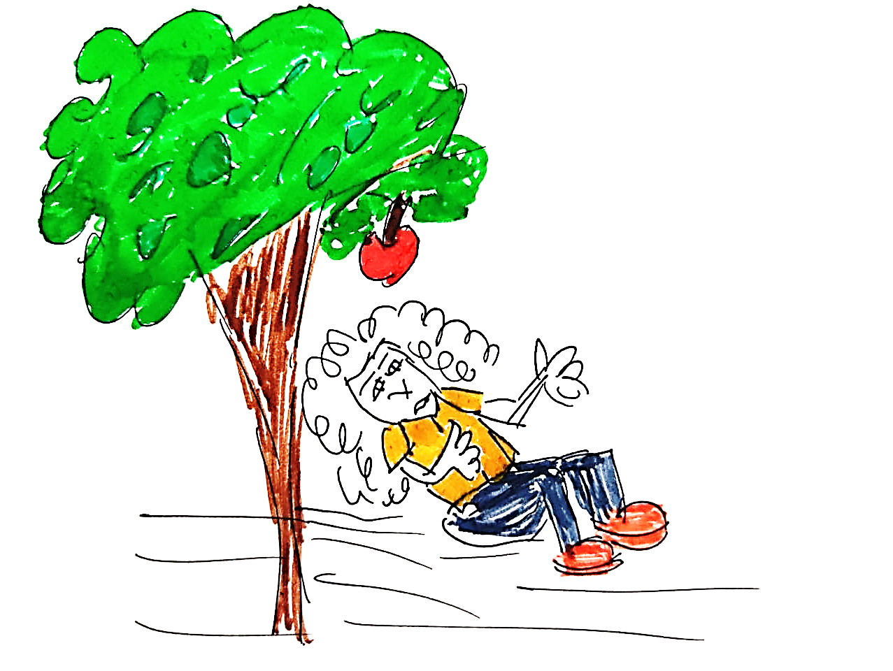

At dawn, all the in-animates woke up with an alarm sound from Alexa.

[RING!! RING!!!! RING!!!!!!]

Hey guys, wake up! Let us start the planning of our maiden trip.

All of them meet in the hall and decide.

[Spoon] Where shall we go? I do not know.

[Toothbrush] Do not ask me my world has been stinky and sharp till now. I do not know anything about the outside world.

[Alexa] Hmm…. Yes! We can go to the Seven wonders of the World!

The Seven Wonders of the World are The Great Wall of China, The great pyramid of Giza, Taj Mahal, Christ the Redeemer, Colosseum, Eiffel Tower, and Leaning Tower of Pisa.

They are places which are preserved as tourism sites. They are in different

parts of the world.

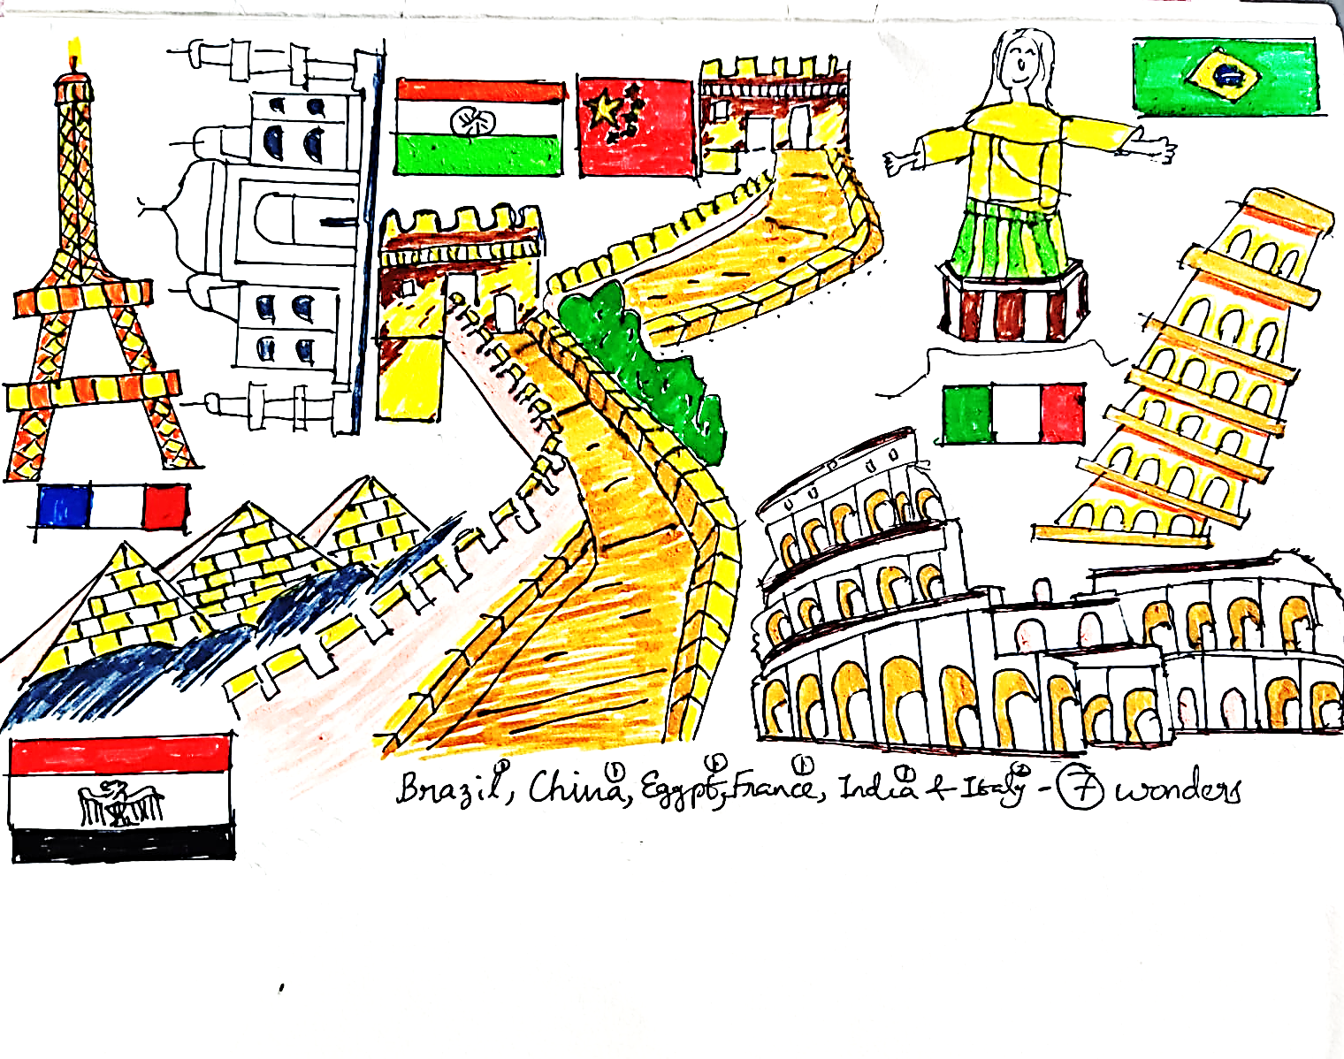

[Alexa] We can use a helicopter to travel short distances and an aeroplane to travel long distances.

Helicopters, aeroplanes are used to fly and travel fast.

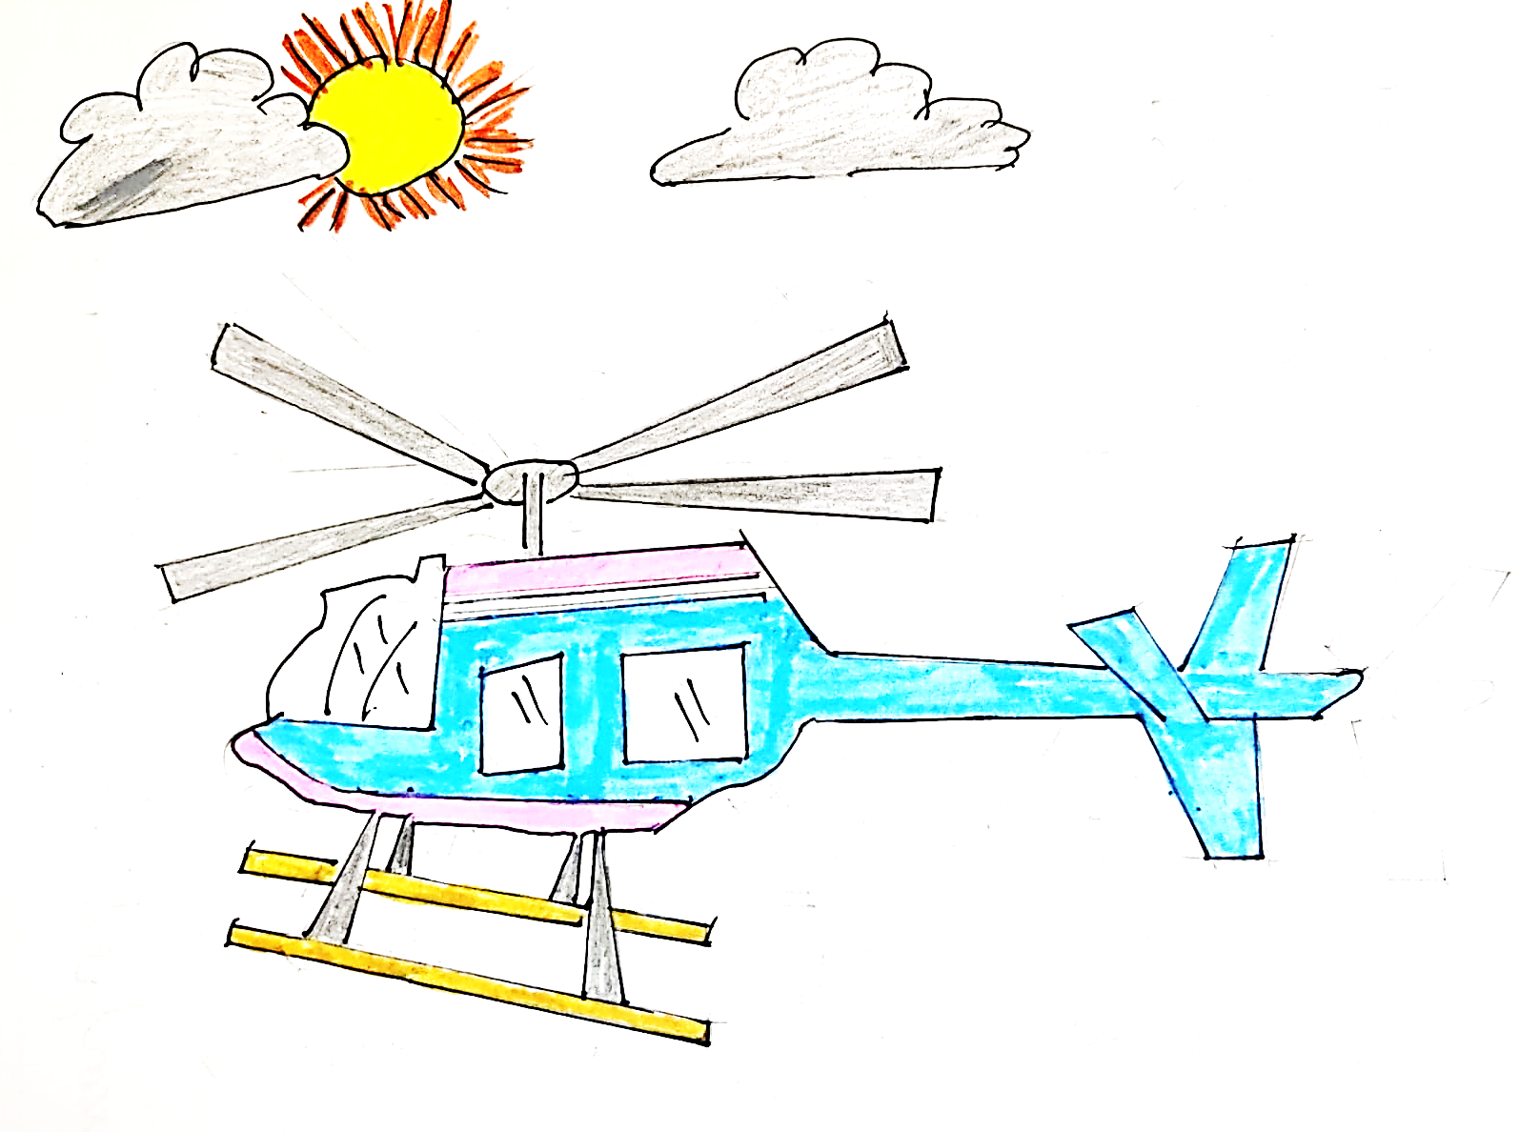

Alexa and his best friends go to the airport. They find a helicopter. It was a brand, new one. Alexa tells the routes to the destination and they reach the beautiful and mesmerizing monument *Taj Mahal.*

CHAPTER 6

*Wow Taj!*

[Alexa] Thanks for the ride, Helicopter! It was a jolly riding you!

[Helicopter] No problem, Alexa, Helicopter always at your service!

All the inanimates go down a narrow pathway to reach the *Taj Mahal.*

On their left, is a toy shop. All the toys were dancing on the road.

Alexa disliked the roads. All roads were cranky. The footpaths were unimaginable.

It was not even and clean.

When the toys were dancing on the road, their feet had become dirty, but they did not bother.

Alexa was staring and glancing at one toy. Alexa’s favourite toy the Rubik’s Cube.

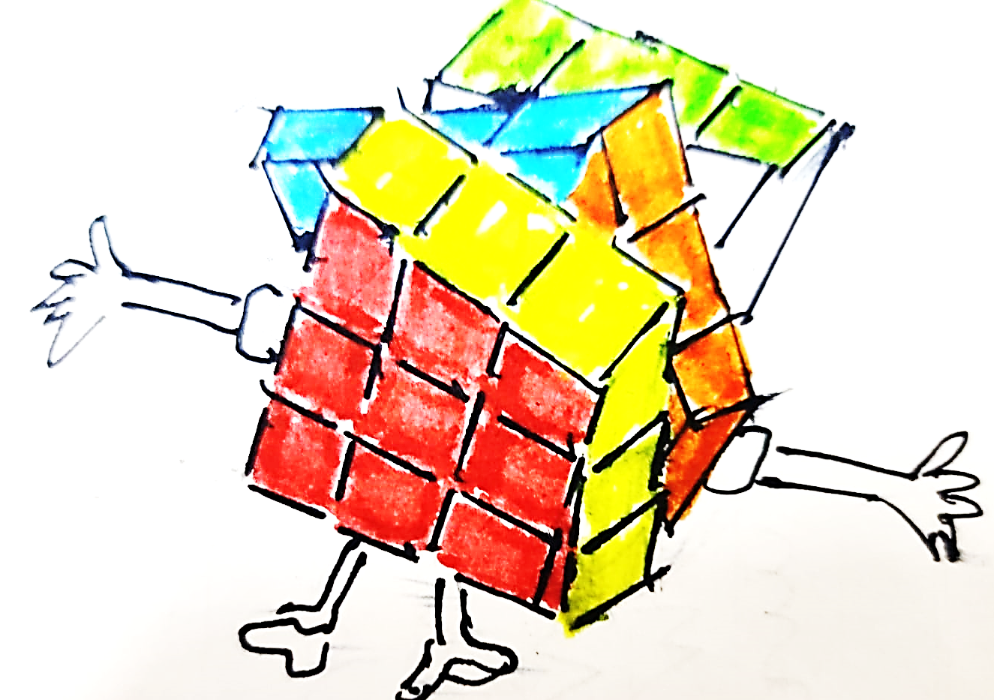

There were so many toys happily roaming in the bazaar, it was like watching Toy Story.